State Diagrams
- Tenant (Done by: Anisa Domi)
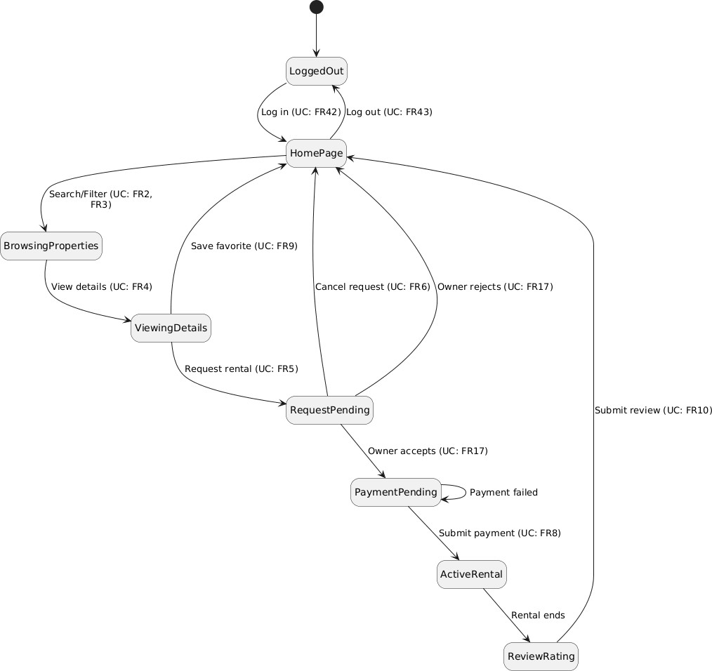

- Property owners (Done by: Haidi Toto)

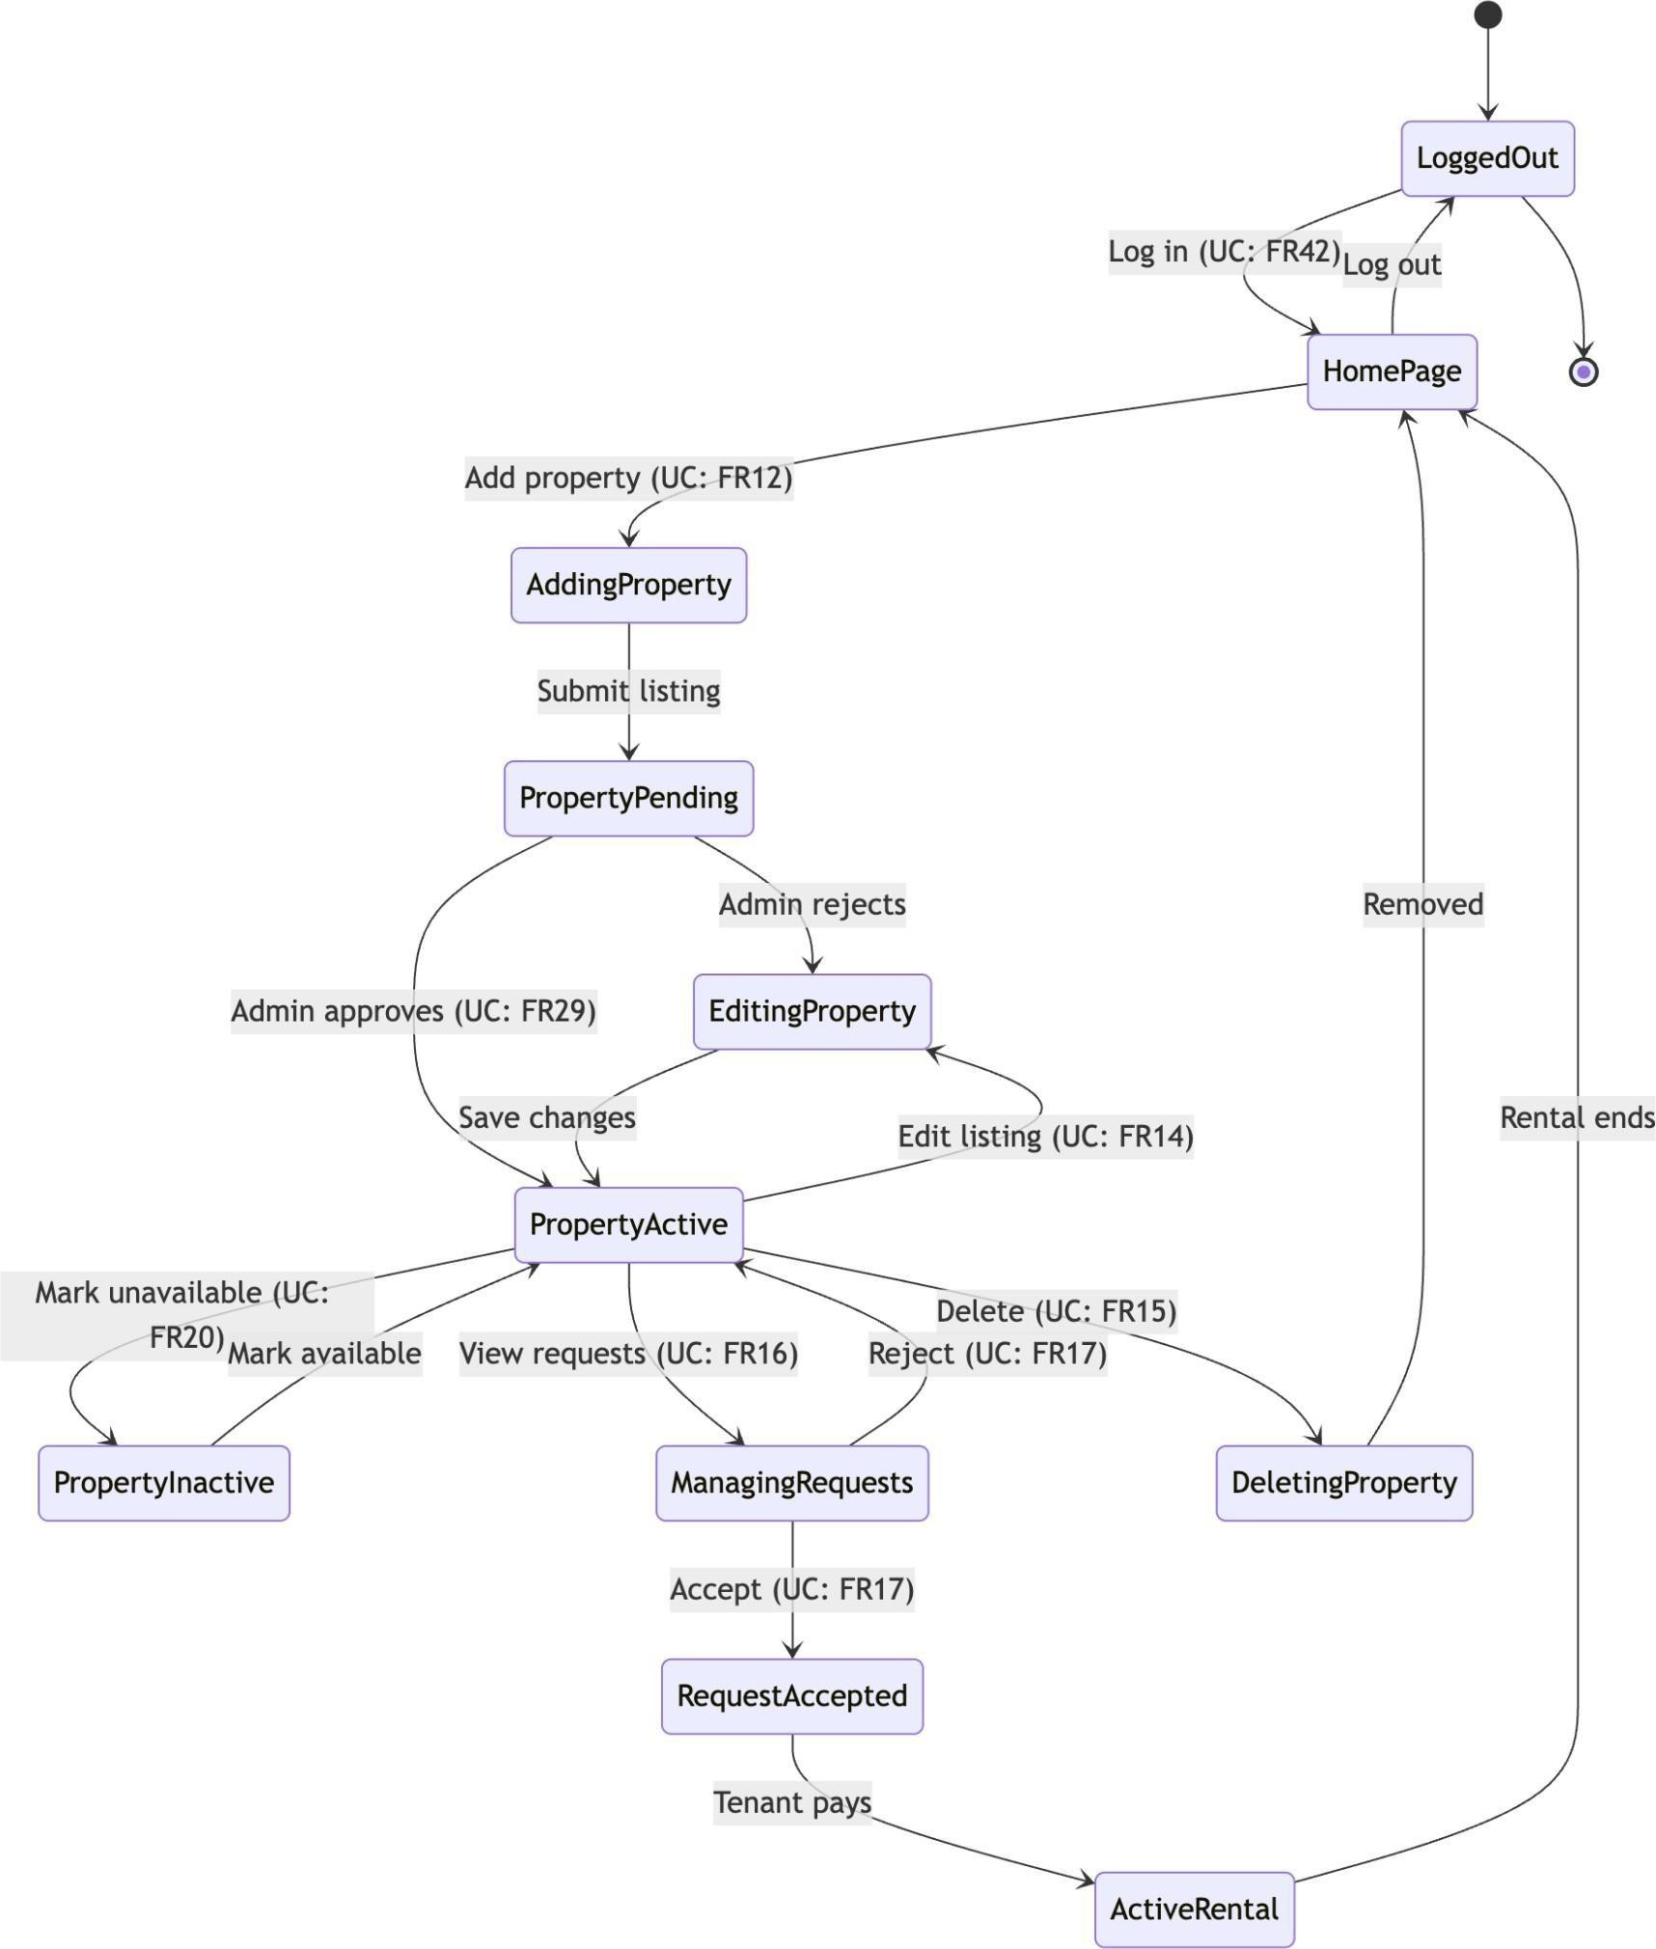

- Administrator (Done by: Ledio Tafciu)

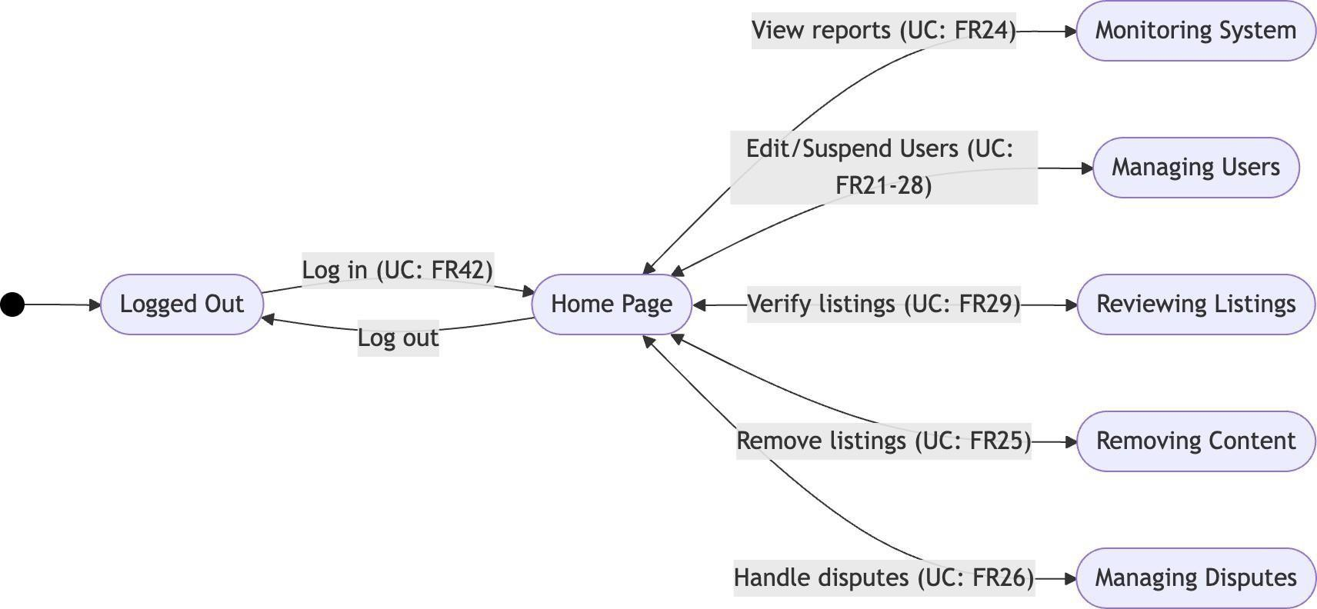

- Manager (Done by: Matias Bali)
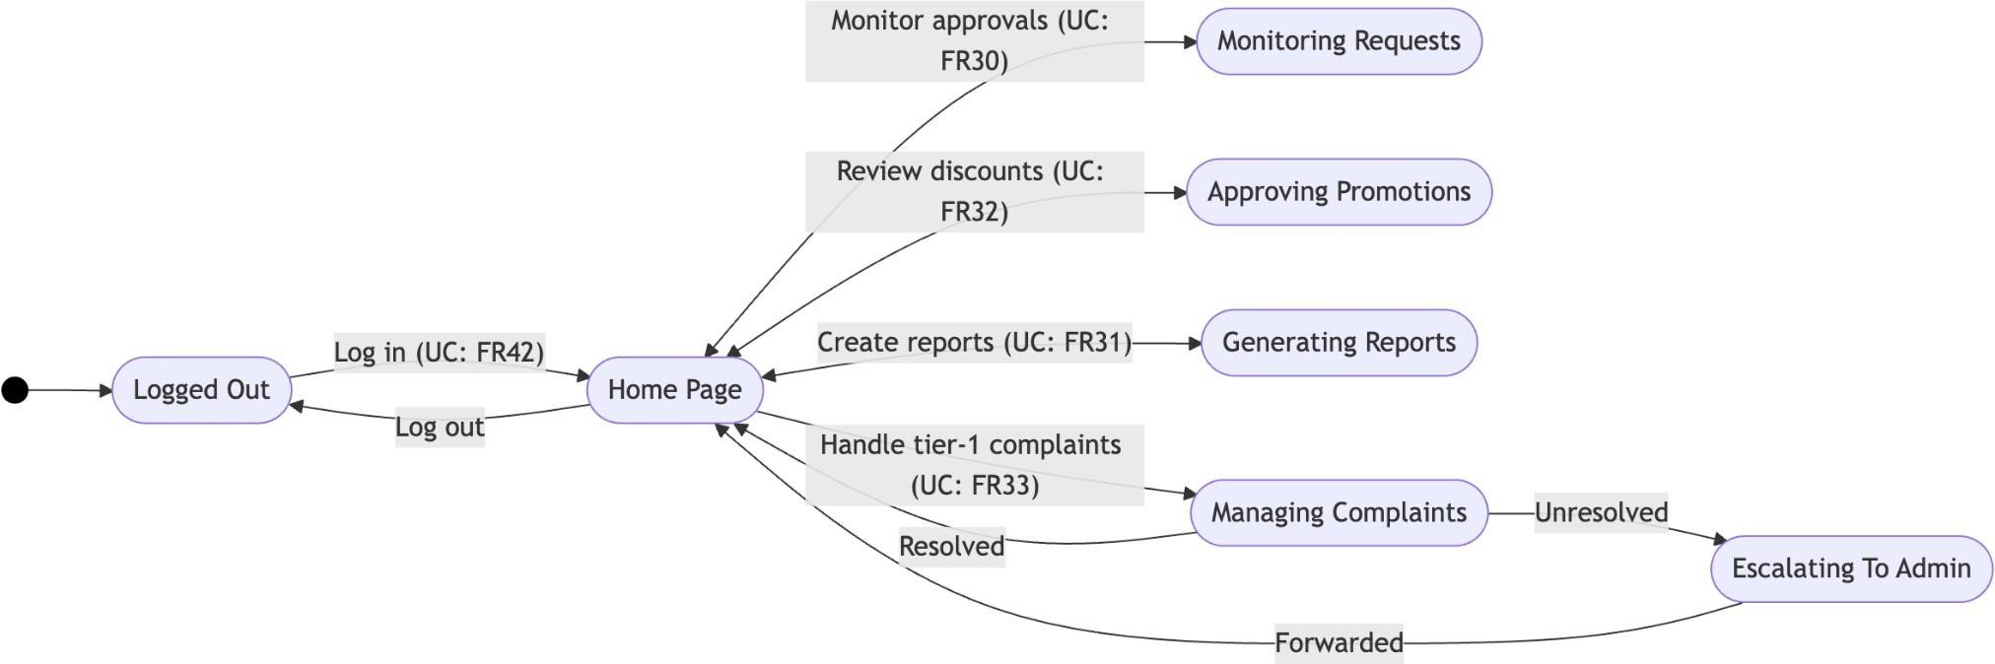

- Finanicer (Done by: Ornelt Lemellari)
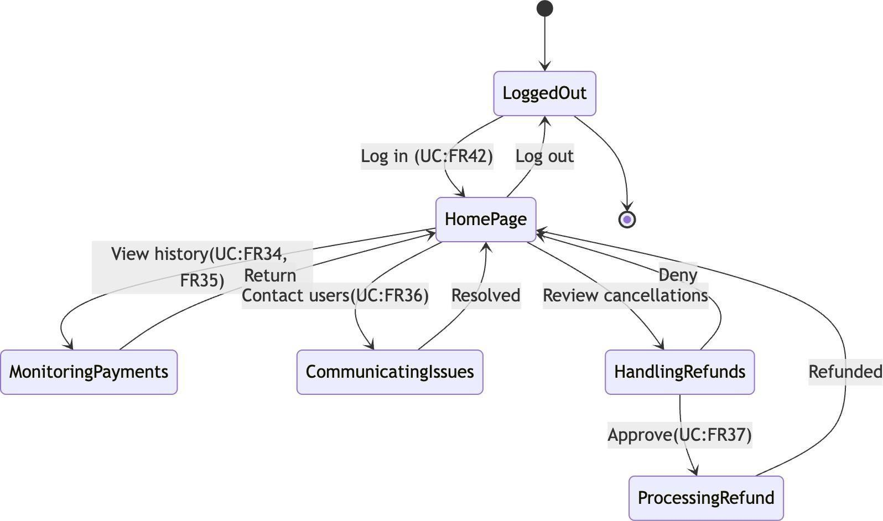

- HR (Done by: Desard Lybeshari)
